- Socio-cultural Approach

- Norman Fairclough (born in 1941) is an emeritus Professor of Linguistics at Lancaster University in England. He is one of the founders of CDA as applied to sociolinguistics. He:

  - Assumes that any case of language is a communicative event.
  - Assumes that CDA is an interdisciplinary approach to the study of discourse that views language as a form of social practice.
  - Is concerned with how power is exercised through language.

- Fairclough’s model for CDA: The model consists of three categories – in this model called dimensions that may be summarized as follows:

- Analysis of text: analysis at word level (can be speech, writing or images or a mixture of them). Includes the description of linguistic features of concrete instances of discourse, that is choices and patterns in vocabulary.
Discourse is the collection of words and characters we choose when we write or speak. By choosing certain words, we show our attitude to the subject.

- Analysis of discursive practice: (analysis at text level) is concerned with the analysis of discursive strategies employed in the production, consumption and distribution of texts. In other words, analysis of texts at this level is concerned with the ways texts are embedded within and relate to social conditions of production and consumption.

- Analysis of social practice: (analysis at norm level), about standards of society or organization. The study is expected to focus on the ideological effects and hegemonic processes in which discourse is seen to operate. In other words, the analysis is on the social context in which the text is produced. It takes into consideration social and cultural relations and structures that constitute the wider context of the discursive practice.

- Fairclough's analytical approach assumes that language helps create change and can be used to change behavior. Language becomes a power tool.

- Corresponding to three dimensions of discourse mentioned above Fairclough distinguishes three stages of critical discourse analysis:
Description: is the stage which is concerned with formal properties of the text.
Interpretation: deals with the relationship between text and interaction (text is seen as the product of a process of production, and as a resource in the process of interpretation).
Explanation: focuses on the relationship between interaction and social context (social determination of the process of production and interpretation, and their social effects).

- Fairclough’s Model of Critical Discourse Analysis

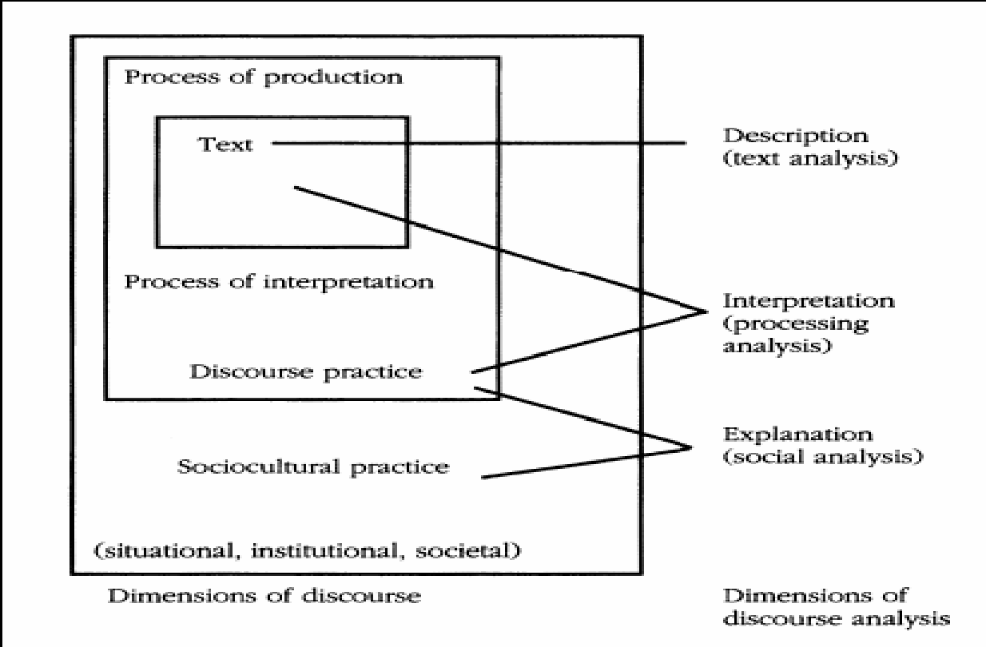

- This method is pragmatic and problem oriented. First, setting out to identify and describe the social problem to be analyzed. Then, going on with the structural analysis of the context, then the interactional analysis focusing on linguistic features (such as agents, time, tense, modality and syntax), and finally, conducting an analysis of interdiscursivity, which seeks to compare the dominant and resistant strands of discourse.

